

Reception
Welcome Booklet

Croeso i’r Dosbarth Derbyn

Living and Learning Together.

Welcome/Croeso

Starting school is a very exciting time and our aim at Lakeside Primary School is to ensure that this is happy and memorable. We are looking forward to welcoming our new children and their families.

We hope this booklet will be helpful and make the transition from home or nursery to school as smooth and as stress free as possible and address any queries you may have.

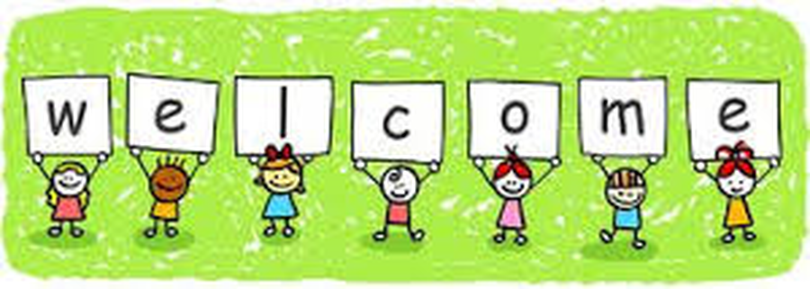
Useful Information

Lakeside Primary School
Ontario Way
Lakeside
Cardiff
CF23 6HB
Telephone: 02920 767050
Email - School Office: lakesideprimary@cardiff.gov.uk

Pennaeth/Headteacher: Mrs Mitchell
Aims of our Reception Class

- We aim to provide a welcoming and happy atmosphere where children feel safe and secure.

- We know that children learn best from first-hand experiences and young children develop at different rates and in different ways. We aim to provide experiences appropriate to each child’s stage and development.

- We encourage your child to become an independent learner by enabling them to make decisions and choices.

- We provide a stimulating environment and introduce your child to the six areas of the Curriculum for Wales.

- We aim to support your child to become:

- ambitious, capable learners, ready to learn throughout their lives
- enterprising creative contributors, ready to play a full part in life and work
- ethical, informed citizens of Wales and the world
- healthy, confident individuals, ready to lead fulfilling lives as valued members of society
- (Curriculum For Wales)

- We strive to develop a positive partnership between home and school. As parents and carers you have a critical role to play in preparing your children for starting school. Please ensure that they see this time in their lives as exciting and fun. When parents and teachers work together, as one team, children will flourish.

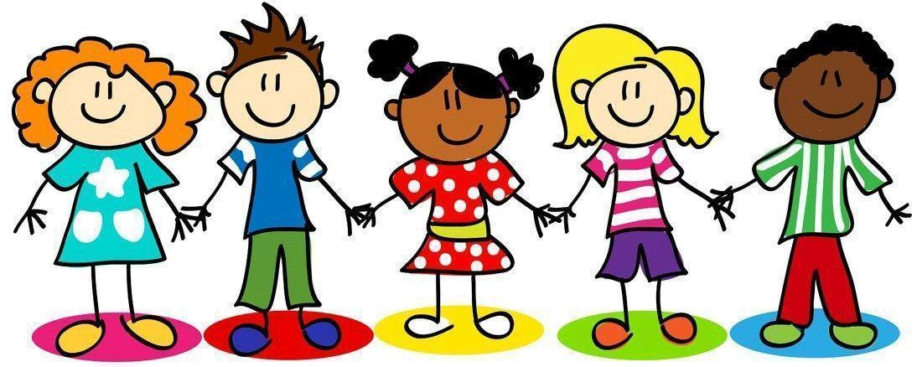

Starting School/Dechrau Ysgol
We are aware of the diverse needs of all our children and that starting school can be just as anxious for parents as it is for the child. Some children will start school without looking back, others might find it more difficult. If your child does get upset, stay cheerful. Reassure your child you love them and will see them later, smile and say goodbye. Sometimes it is necessary to leave your child upset, but our staff are highly trained to deal with these situations. Most children are fine within five minutes of leaving their parents or carers.
The Reception class entry to school is staggered over several days. You will receive a letter telling you the day and time your child will be starting.
Please ensure your child arrives on time to school every day. The classroom doors open at 8.45am and close at 8.55am to allow children to come in safely. Your child will miss valuable instructions and introductions if they arrive late as the teacher will have begun the first lesson. Please ensure your child is collected on time. Reception children finish school at 3.15pm and are let out of the classroom doors onto the playground one at a time when the staff can see who is collecting them. They may become upset if you are late. If at any time you are going to be unavoidably late, please telephone the school to let us know.
In order to ensure your child’s safety, please keep your child with you at all times on the school premises and make certain your child has entered the school before leaving.
Please could your child leave a set of spare clothes in a bag on their peg. A pair of pants, socks or tights and a pair of trousers or a skirt. These need to be clearly labelled with your child’s name. They will be used if your child has an accident in school.
Please do not allow your child to bring toys to school. These can easily get lost or broken and this causes a lot of distress. If we require items from home, e.g. as part of our project work, you will be notified by the class teachers.

Preparation/Paratoi
One of the main factors that give your child confidence when he or she first comes to school is being able to cope with practical things independently. The best preparation for school is helping your children to feel good about themselves, to believe they already have many skills and to give them the confidence to ask for help when they need it.
It would be most helpful if your child could:
- Use the toilet as independently as possible. Encourage your child to call it a toilet. Teach them to ask “Please may I go to the toilet?”
- Flush the toilet.
- Wash their own hands thoroughly with soap. Dry their own hands.
- Use a knife, fork and spoon.
- Dress and undress without help. Put on and take off their own coat. Put on and take off shoes and socks or tights. Velcro shoes are best.
- Generally tidy away toys, books and games.
- Share toys and wait for their turn.
- Communicate his/her needs clearly.
- Use good manners, say ‘please’ and ‘thank you’.
- Say their name clearly when asked.
- Use scissors safely.

What we need to know/Rydyn ni angen gwybod

We need to know if your child has any medical conditions or allergies. You will go through some paperwork when your child starts school but please update the class teacher if circumstances change.

For the health and well-being of children and staff please keep your child at home if they are unwell. In the case of absence, please telephone the school or provide your child’s teacher with a written explanation. Any unexplained absence is recorded as unauthorised.

If your child has been vomiting due to a sickness bug, then they should stay at home for 48 hours after vomiting and diarrhoea has stopped. (NHS guidelines)

We need to know how to contact you in an emergency. Please make sure you complete the emergency contact forms. Please remember to notify us if any of the telephone numbers change or if you move to a new address.

We need to know who will normally collect your child from school. If somebody different will be collecting your child at any time during the year, please make sure the class teacher knows.

If you have any worries or concerns staff are available for a quick chat at the end of the day. The beginning of the day is a busy time settling the children.

Please inform staff of any situation at home that might affect your child in school, e.g. family bereavement, parent admitted to hospital, separation. We are a thrive school and have trained members of staff to support children’s wellbeing.

School Uniform/Gwisg Ysgol
We believe that wearing a school uniform helps to foster a sense of pride and belonging to our school. All children are encouraged to wear school uniforms. The school colours are navy or white polo shirts, green school sweatshirt or cardigan and navy trousers, skirts or pinafores. Summer dresses are green and white check. Sweatshirts and cardigans can be purchased from YC Sports or from other supermarkets or shops. Lakeside PTA sells preloved uniforms at reduced prices. Shoes are to be black in any practical style. Velcro fastenings are best so that the children can take them on and off independently.
All clothing must be clearly labelled to ensure we can trace items of missing clothing.
With the exception of small studs for pierced ears, jewellery should not be worn to school.

P.E./Games/A.G/Chwaraeon

The children wear their PE kit to school on the same day each week. We will inform you which day this will be when your child starts school. The children are encouraged to wear a white t-shirt, black or navy shorts, joggers or leggings. The children need to wear trainers or gym shoes. Please ensure all items of clothes are clearly labelled.

Outdoor Learning/Dysgu Awyr Agored

In Reception, much of the learning takes place in our fabulous outdoor areas. Please could your child bring a warm coat to school when it is cold, a waterproof coat when it is wet and wear suitable footwear. When the weather is hot, it is advisable to apply sun cream to your child before they come to school. Children can bring sun cream into school, clearly labelled with your child’s name, to use later in the day.

Healthy Eating/Bwyta’n Iach

We promote healthy eating at Lakeside Primary School and for a mid-morning snack your child will be offered milk and will need to bring a piece of fruit to school. Your child may also bring a reusable bottle filled with water. Please label this with your child’s name. Please do not send sweets or other snacks into school with your child. The children are not allowed to bring cakes, sweets or any other foods to school to share when it is their birthday.

It is vital that if your child has any special dietary requirements that you let us know, e.g. allergies, diabetes.



Lunch Time/Amser Cinio
School lunchtime is from 11.45am until 1pm. Your child may have a funded school dinner or bring a packed lunch to school. This is an important time to develop the children’s social skills. When the children start school the teachers, teaching assistants and our midday supervisors will support your child. We will help your child in the dining hall and also supervise children in the playground or in the classroom when it is raining. It would be very helpful if you make sure that your child is able to handle a knife and fork correctly, although staff are always willing to help when necessary.
If your child has medically diagnosed special dietary needs, please let us know well in advance and arrangements can be made with the kitchen staff.
Should you wish your child to have a packed lunch please make sure the lunch box is clearly labelled. No fizzy drinks, glass bottles or containers, chocolates or sweets are allowed. Please do not include nuts, as there are children in school who have severe nut allergies. Allow at least a few weeks before changing between dinners and sandwiches allowing time for your child to settle into their choice. Frequent changes cause disruption for the children, kitchen staff, class teachers and our school administrators.
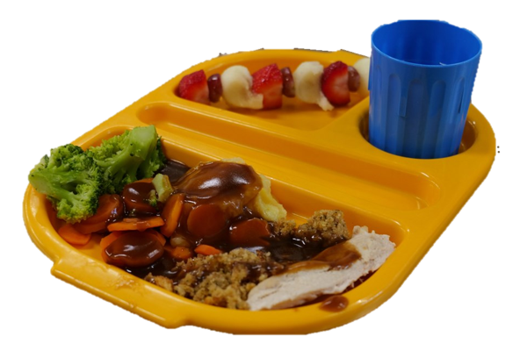

Homework/Gwaith Cartref
The children enjoy sharing their learning with you at home. This is an important aspect of school life. In Reception this consists of:
- A book bag that contains a library book chosen by your child for you to read to them
- A school reading book selected by the teacher at the appropriate level for your child.
- Seesaw. Some homework will be set on seesaw. This is an online learning platform. Your child will be given login details when they start school.
- Bug Club. This is an online reading resource. Your child will be allocated digital books to read each week.
- Bug club homework is set every week. It is important to support your child whilst completing the work but it is vital that the homework is your child’s own work.
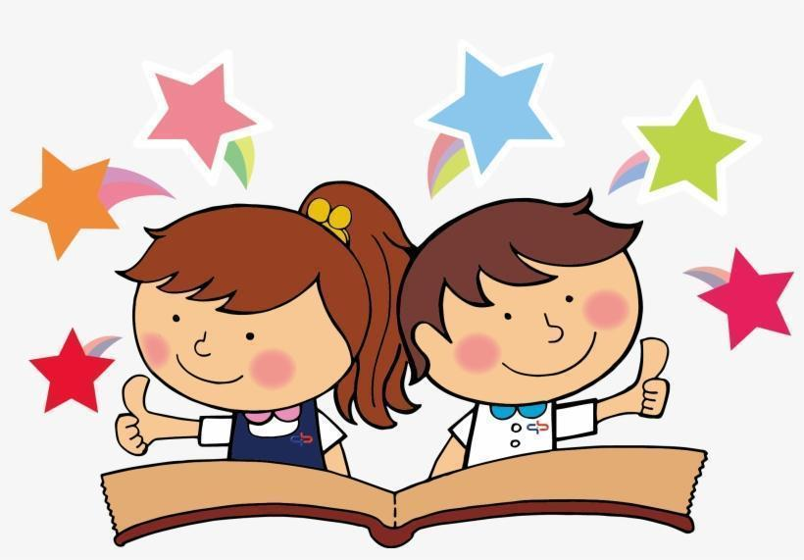

The school website is also an excellent place to find out more about Lakeside Primary School and keep up to date with events. Each year group has their own class page which is updated with curriculum information.

https://www.lakesideprimaryschool.co.uk/

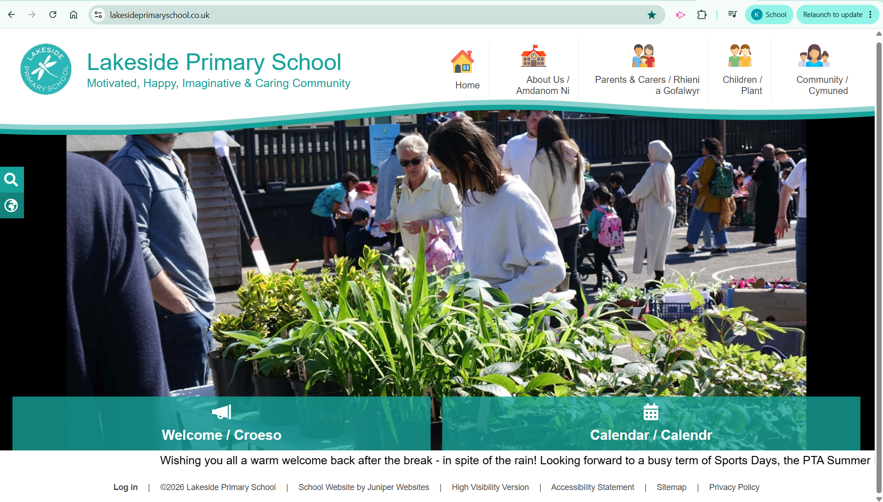

We value the links between home and school and view the process of education as a partnership with pupils, staff and parents playing a vital role.

