

Reception
Reading Information for parents and carers

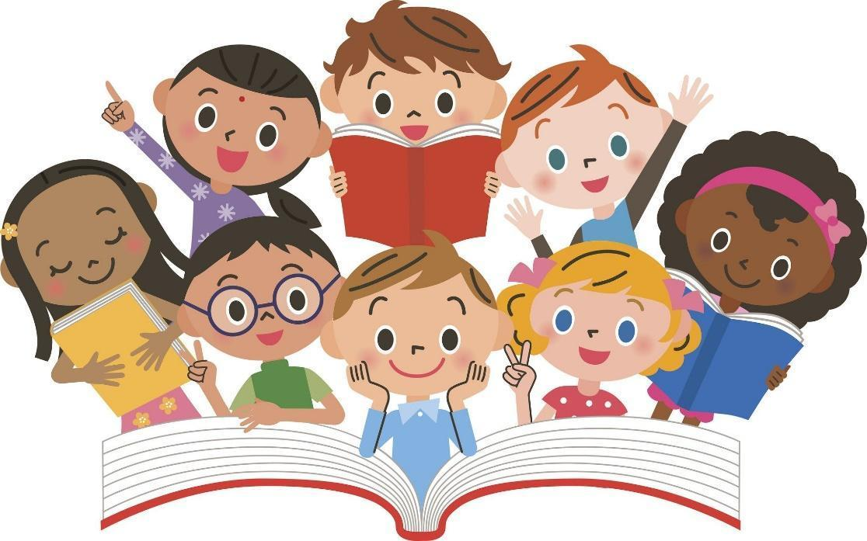

Being able to read opens the doorway to learning and exploring the world in which we live.

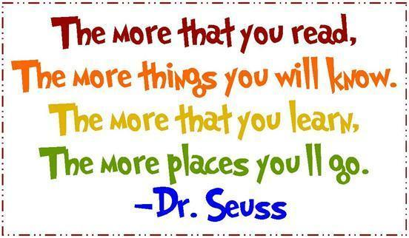

We strive to develop a positive partnership between home and school. As parents and carers, you have a critical role to play in supporting your child with their reading. We would like the children to develop a love of books and enjoy reading. When parents and teachers work together, as one team, children will flourish.
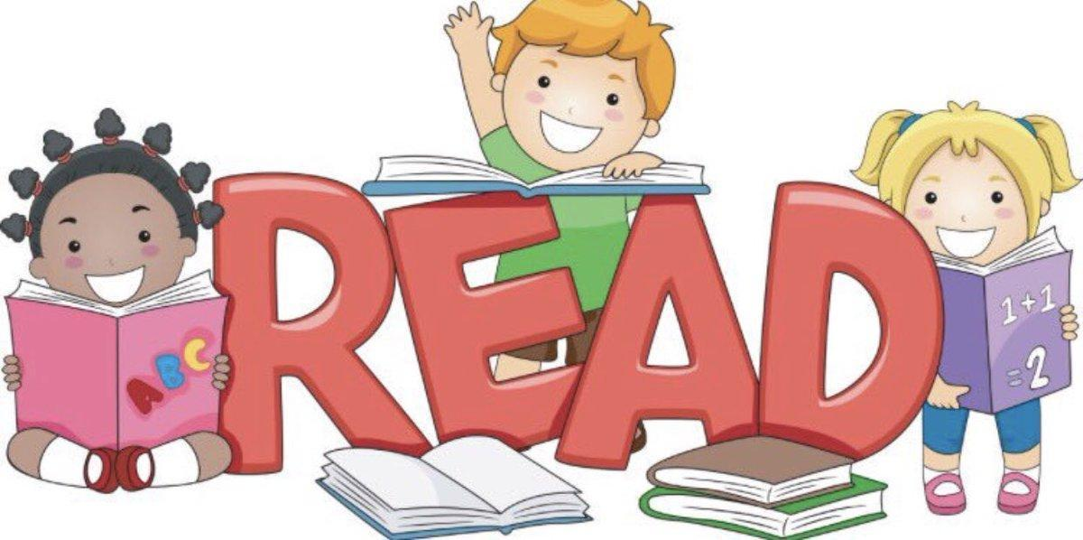

Children use discussion to help them learn to read. They need to be able to talk about what they see:
- How does the little girl feel?
- How can you tell that she is happy?
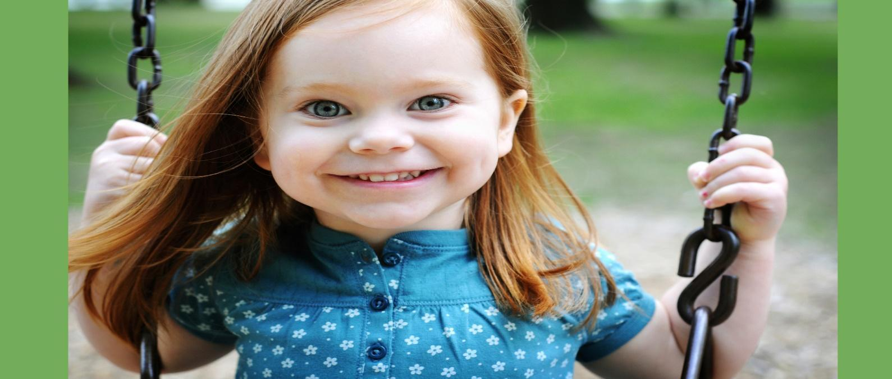
- What do you think is making her happy?

Children use their memory to help them learn to read. From a young age children will begin to recognise signs, such as these, around the environment.




They will use their memory to learn to read whole words.

I the to go we

We call these tricky words as they do not sound out.
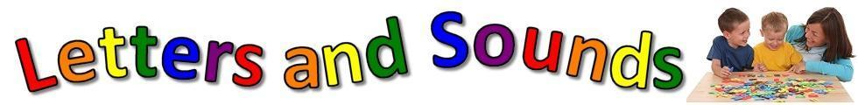
Children use phonics to help them learn to read. We teach children the letter sounds or phonemes using a resource called letters and sounds.

The first letter sounds or phonemes we teach are:

s a t p i n

Children can read and write lots of words with these phonemes, for example:

at in an pin sat tin tap sip pat

Once all the initial letter sounds or phonemes are taught we teach the children consonant diagraphs: ch sh th ng and then vowel digraphs and trigraphs: ai, ee, igh, oa, oo, ar, or, ur, ow, oi, ear, air, ure, er.

Children use pictures to help them read. Let your child look at the pictures carefully before they try to read the text on a page.
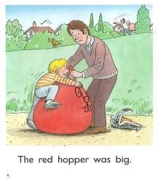

Children need to understand what they are reading in order to enjoy it and for it to make sense.
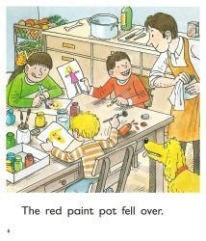

Your child will bring home:

- A Library Book. This will be a book that your child has chosen to take home. We are not expecting your child to be able to read this book. This book is for your child to enjoy and develop a love of reading. Listening to stories is very important for children, even when they are fluent readers. They need to hear good role models in order to develop their speaking and listening skills and for them to develop into good readers.

- A Reading Book. This is leveled using a colour band code system. Your child may start with a lilac book. This book has no words inside. Please encourage your child to talk about the story. Once your child can read a bank of keywords, they will bring home a pink book. These books are simple storybooks with words to read. Your child should be able to read 90% of the book independently. Please do not worry if your child reads this with ease as children need to succeed to gain confidence and enjoy reading.

- A Word Book. Each week the teacher will put word cards in this book for your child to learn to read. Some of these words will be tricky words and will not sound out. Your child will learn to remember these words. Your child may be able to sound out other words using their phonic skills. These words are taken from a specific list. Our aim is that your child will recognise and read these words fluently. Please do not add your own words to this book. Games to help your child to learn to read these words are listed below.

- Daily Reads. Your child may change their reading book every day if they want to. The ‘daily read’ books are given out in a clear zip wallet. The children chose these books themselves at their appropriate level.

- Bug Club. Your child will be allocated a book every week onto their Bug Club online reading library. Reading these books alongside their bookbag book, will help to develop their work recognition and fluency.
This is how they log in: Google: Active Learn: Login Click ‘Log in’ Username: first 3 letters of their first name followed by first 3 letters of their surname (no gap)
Password: changeme (lower case c) School code: qlq7 Click on ‘My Library / Click on the door When your child has read a book, they will be rewarded with a sticker, which can be seen under the heading ‘My Rewards’

Bingo: Write the words given to your child from their word book onto a piece of paper on a grid. When your child can read the word tick it or place a cheerio on the word.
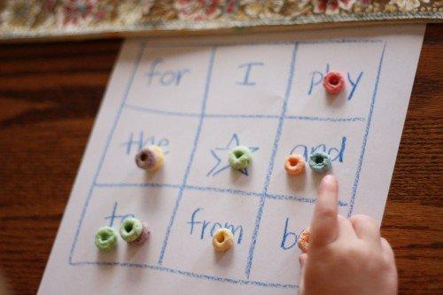

Splat: Write the words given to your child from their word book on a piece of paper. Place on the floor, adult calls out the word and the child splats the word with their hand or a fly swat.
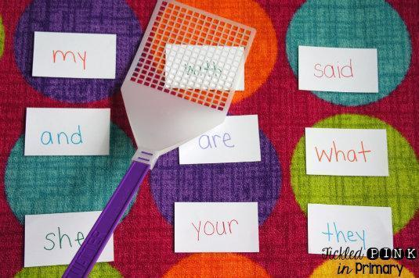

Cup crash: The child reads the word on the cup and if correct, stacks the cup onto the floor. Knock the completed tower down with a ball. Use the same word more than once on different cups to encourage speed and fluency.
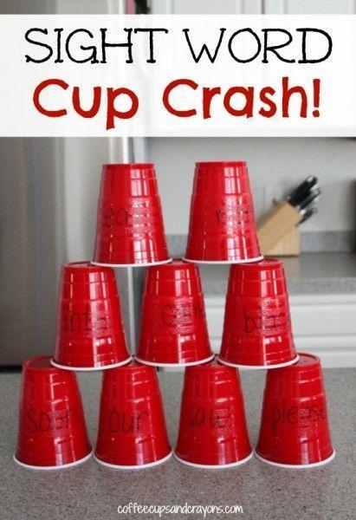

Ways to support your child with reading at home

- Share the excitement with your child when they bring their reading folder home.
- Find a good time and place to hear your child read. If they are tired, hungry or it is too noisy they may not be able to concentrate.
- Spend time looking at the front cover of the book and reading the title.
- Encourage your child to hold the book and turn the pages themselves.
- Talk about the book with your child. Ask questions about the book, for example, how do they think a character is feeling or what do they think may happen next?
- Encourage your child to use the pictures to help them read.
- Encourage your child to point to each word as they read.
- Please return your child’s book and book bag on the allocated day.

In order for children to become able and independent readers they need to have:
- Enjoyment and confidence: Children who will become lifelong readers because it is useful and enjoyable to do.
- Fluency: Children who can read at a comfortable speed with appropriate expression.
- Accuracy: Children who can ‘decode’ words they are reading without interrupting the flow.
- Understanding: Children who can follow the content of what they read.

We hope that you found this booklet useful and enjoy sharing a variety of books with your children.

